The analyses mainly base on the wave’s results.

The goal should not be to get rid of *all* icons, except for the errors which may represent an end user issue, but must be manually assessed. Other icons are presented to facilitate human analysis of accessibility and structure of the page.

These icons stand for:

**Errors**: - Issues that will impact certain users.   
 - Failures to meet WCAG.  
  
**Contrast Errors**: Text that does not meet WCAG contrast requirements.  
  
 **Alerts**: - Elements that may cause issues.  
 - An evaluator must decide the impact.  
  
 **Features**: Elements that improve accessibility when implemented correctly.

**ARIA**: - Presents accessibility information.  
 - Reduces accessibility when used incorrectly; often used incorrectly.

Pathways gaps:

1. Replace all tags with semantic tags as much as possible

Such as: header、h1-h6、main、footer

1. All svg icons need to be analyzed for their purpose (Majority for us)  
   - If icons are purely decorative, The aria-hidden=true attribute is added so that your icons are properly accessible (invisible).  
   - If icons have semantic meaning, you need to provide a text alternative only visible to assistive technologies.

``  
import IconButton from '@material-ui/core/IconButton';  
import SvgIcon from '@material-ui/core/SvgIcon';  
  
<IconButton aria-label="delete">  
 <SvgIcon>  
 <path d="M20 12l-1.41-1.41L13 16.17V4h-2v12.17l-5.58-5.59L4 12l88 8-8z" />  
 </SvgIcon>  
</IconButton>  
``

1. All click events need to be added press Enter events at the same  
   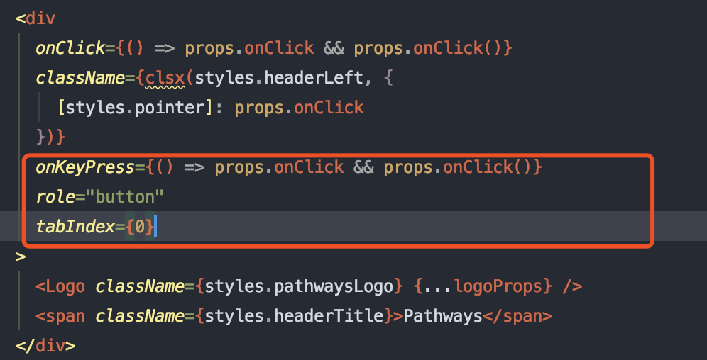
2. All image tags need to be added ‘alt’ attribute

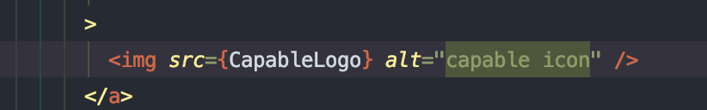

1. All form tags such as `input` or `textarea` or `dropdown` need to be added label  
   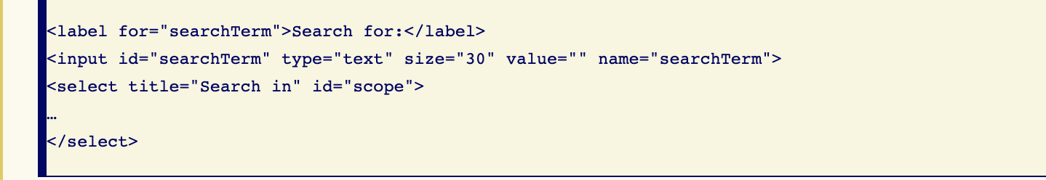

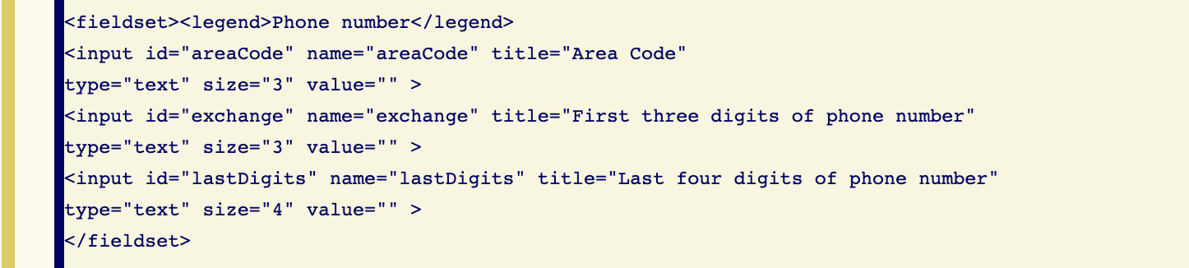

1. All elements which can be focused need to be add `tabIndex` attribute
2. All progress or sider components need to be added correct aria-* attribute
3. Contrast Errors need to fix, The others need to manually assess.

